This box contains  Dry Ice!  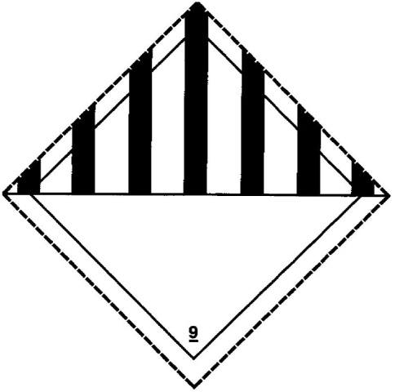  LS-Jobaid-5389 Rev 1 | This box contains  Dry Ice!  LS-Jobaid-5389 Rev 1 | This box contains  Dry Ice!  LS-Jobaid-5389 Rev 1

